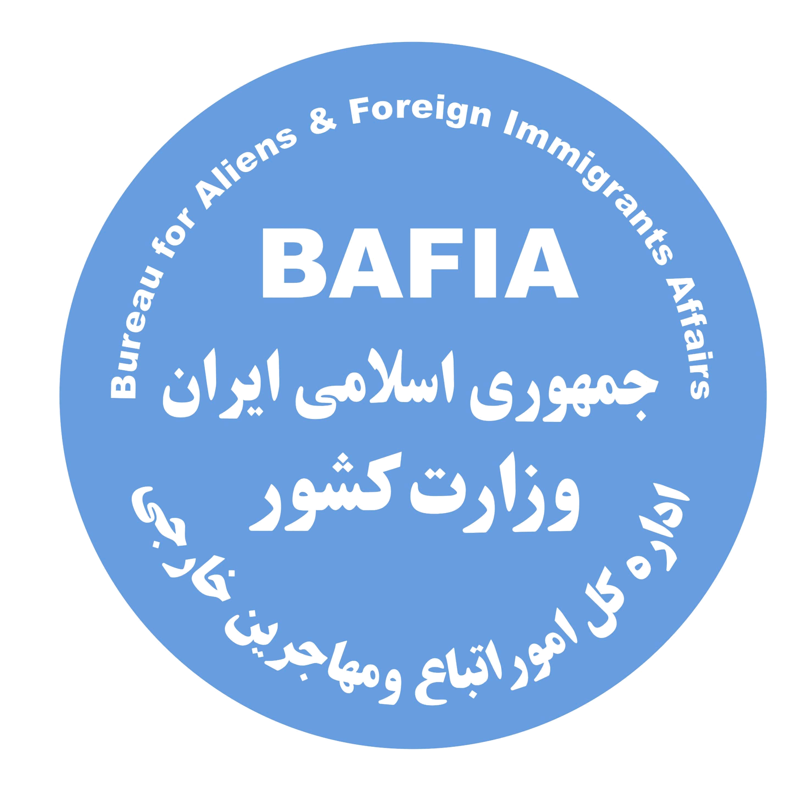
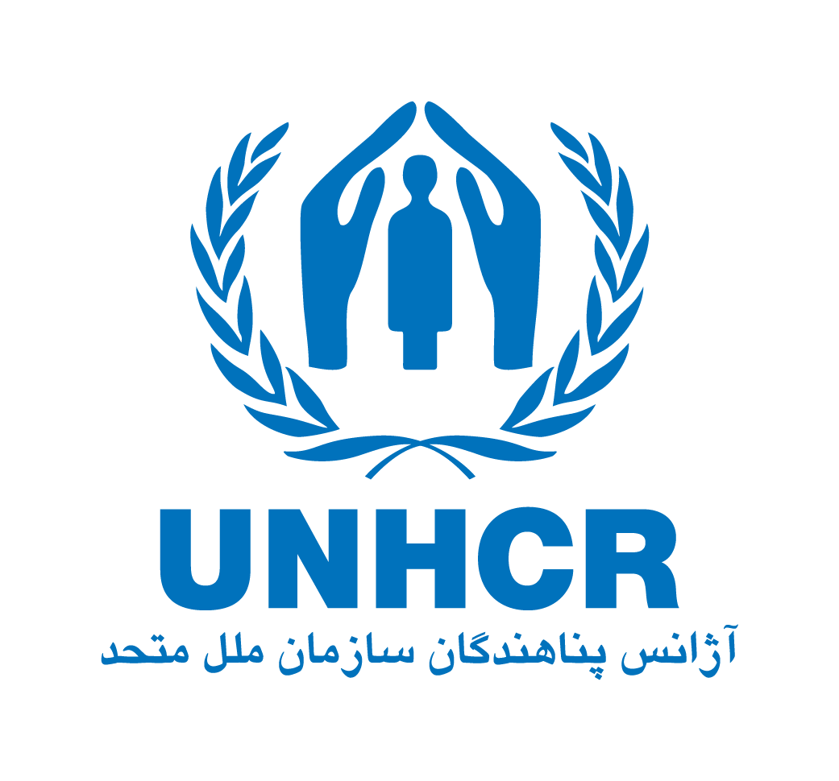

Return Guide

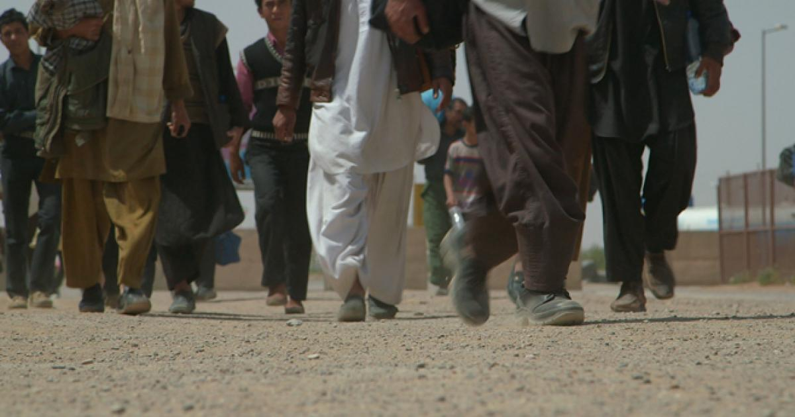

For the Voluntary Repatriation of Afghans from Iran

Bureau for Aliens & Foreign Immigrants’ Affairs (BAFIA)
&

United Nations High Commissioner for Refugees (UNHCR)

If you are a valid Afghan Amayesh card holder and wish to repatriate, please read carefully the information below on Voluntary Repatriation procedures
Repatriation by Land
STEP 1 - approach your nearest UNHCR Office
Before you make up your mind on repatriating to Afghanistan gather as much information as possible from trusted and reliable sources, particularly on the security situation and other aspects such as basic means of livelihood and services in your intended final destination.

You are encouraged to contact your nearest UNHCR Office for Voluntary Repatriation counselling before making the decision to return.

Before physically approaching the UNHCR Office please call the UNHCR hotline to obtain an appointment. Please find contact details in page 8 of this leaflet.

STEP 2 - deregister with BAFIA and obtain a Laissez-Passer
Once you have made the decision to return, you need to deregister with BAFIA in your province of registration and obtain a Laissez-Passer to be allowed to travel to the Dogharoun Border Crossing Station.

STEP 3 – obtain a Voluntary Repatriation Form from UNHCR
Approach the UNHCR office closer to your place of residence to receive counselling and to fill in and sign the Voluntary Repatriation Form.

Make sure to approach the UNHCR office with all your dependents who will be repatriating to Afghanistan with you to be able to successfully complete the Voluntary Repatriation procedures.

The Voluntary Repatriation Form is a document issued by UNHCR to returnees confirming their intent to return voluntarily to Afghanistan with the assistance of UNHCR.

It is important that you provide accurate and correct information to UNHCR at the time of filling in the Voluntary Repatriation Form as this form will not be re-issued in Afghanistan or elsewhere in Iran. In Afghanistan, the Voluntary Repatriation Form will be used as your return document proving that you were a Amayesh card holder in Iran. It will be used as the basis to consider you for reintegration assistance if you meet the eligibility criteria.

You will be given copies of the duly filled Voluntary Repatriation Forms. Please make sure to keep the Voluntary Repatriation Form copies in a safe place during your journey to and in Afghanistan. You will be asked for them during the trip, at the border and in Afghanistan.

STEP 4 – Do not forget the required documentation for travel
Ensure that you have all necessary documents for your travel through Iran to Afghanistan i.e. Laissez Passer, Voluntary Repatriation Form and available Afghan identity documentation (Taskera or Passport, driving licence) and for reintegration in Afghanistan e.g. marriage/divorce certificate, delivery note/birth certificate, death certificate; education documents/certificates; vaccination card and medical records.

STEP 5 – Make your travel arrangements to the border/Dogharoun
Make your transportation arrangement up to the Dogharoun Border Crossing Station. You are advised to travel light and not to take large quantities of luggage so that you do not pay large sums of money for transportation, so that you are able to travel with ease and pass-through customs (see p. 6 for more information).

Ensure that you reach the border before the duration of your Laissez Passer expires and between Sunday-Wednesday 8:00-14:00 and Thursday 8:00-12:00, when both UNHCR and the border authorities are working.

STEP 6 – Approach BAFIA Office at Dogharoun
When you arrive at Dogharoun BCS, approach the BAFIA office for verification of your LP. You will then be referred to UNHCR staff who will advise you on the next course of action.

➲ Be cautious: keep your valuable items with you at all times!

If necessary, you can be referred to the medical team at the Dogharoun Border Crossing Station to make sure that you and your family are physically fit for the onward journey to Afghanistan.

STEP 7 – Crossing the border into Afghanistan
Once you have crossed the border and arrived in Islam Qala in Afghanistan, UNHCR partner will inform you about further procedures in Afghanistan.

➲ UNHCR cannot facilitate border crossing on Iran and Afghanistan national holidays!

Repatriation by Air
UNHCR may facilitate the repatriation of Afghans holding valid Amayesh card who wish to repatriate by air and can afford the cost of their plane ticket and arrange their own transportation to the airport.

Steps 1 to 4 above apply for air repatriation. First approach the relevant BAFIA office to surrender your Amayesh card, receive a travel LP and an Introduction Letter. You should then take your passport and Introduction Letter to the Disciplinary Forces (FARAJA) to obtain an Exit Permit.

Upon obtaining the Exit Permit, approach the UNHCR with your air tickets along with the copy of their LP and/or Amayesh card and to fill in the VRF.

Cash Grant in Afghanistan
UNHCR Afghanistan provides each returnee holding a valid VRF with a one-off cash grant of AFN 26,500 (covering transportation, re-entry, and immediate needs upon arrival). The VolRep grant is provided at the UNHCR Encashment Centres (ECs) inside Afghanistan, located in Nangarhar, Kandahar, Kabul and Herat provinces.

This grant is available at the Encashment Centres in Afghanistan from one day after the Voluntary Repatriation Form has been issued by UNCHR Iran. This means that if you collect the Voluntary Repatriation Form, you will need to make arrangements that allow you collect the cash grant from the appropriate Encashment Centre in Afghanistan one day after receiving the Voluntary Repatriation Form from UNHCR Iran.

In addition, due to the current economic instability in Afghanistan, returnees who return with a VRF from 1 January 2023 will receive a one-time supplemental reintegration cash grant approximately 3 months after arrival in their areas of origin/intended destination. This grant is intended to support reintegration by extending financial support for three additional months. Returnee families will receive AFN 49,400 (for a family of two or more people) or AFN 24,700 (for single individuals).

At the EC, all returnees will receive basic health services, and overnight accommodation when needed. They may receive additional services provided by other partners present in the ECs.

Those returning by air, depending on their areas of destination, can receive their cash grant either at Kabul EC or other ECs/UNHCR offices close to their area of destination in Afghanistan.

The returnees will be advised by a UNHCR staff in Iran which EC to approach when they are issued with a VRF.
Customs Allowances and Restrictions
The Government of the Islamic Republic of Iran will help all repatriating Afghans to move their tools and household belongings with customs exemption unless prohibited goods. To export professional equipment and tools from Iran, a special permit is required. To obtain this permit, please contact your local BAFIA office.

The Government of the Islamic Republic of Afghanistan will assist the sustainable reintegration of returnees and displaced persons by taking necessary measures required for facilitation and acceleration of customs formalities in all border-crossing stations.

Below is a list of some permitted and prohibited items. For a complete list, please refer to UNHCR, or BAFIA or MoRR.

Permitted Items | Prohibited Items
☑ Personal belongings (luggage limitations apply), as long as they are non- commercial.  ☑ Money in Rials and Afghanis and a maximum of US $1,000 or its equivalent in other currencies. | ☒ Any items in commercial quantities.  ☒ Hand-woven carpets, antiques and cultural heritage items are prohibited.  ☒ Subsidized items such as medicine, cooking oil, wheat, flour, stationery, etc.  ☒ Fuel, kerosene, gas oil, petrol and butane gas cylinders.  ☒ MOTORCYCLES (whole or in parts).  ☒ Imported professional equipment, machinery and computers, unless a special permit is obtained.

➲ Each family is allowed to carry a reasonable amount of personal belongings. Customs authorities might tax any item that exceeds the reasonable amount. UNHCR cannot support in such instances.
Dispute Settlement Committee (DSC)

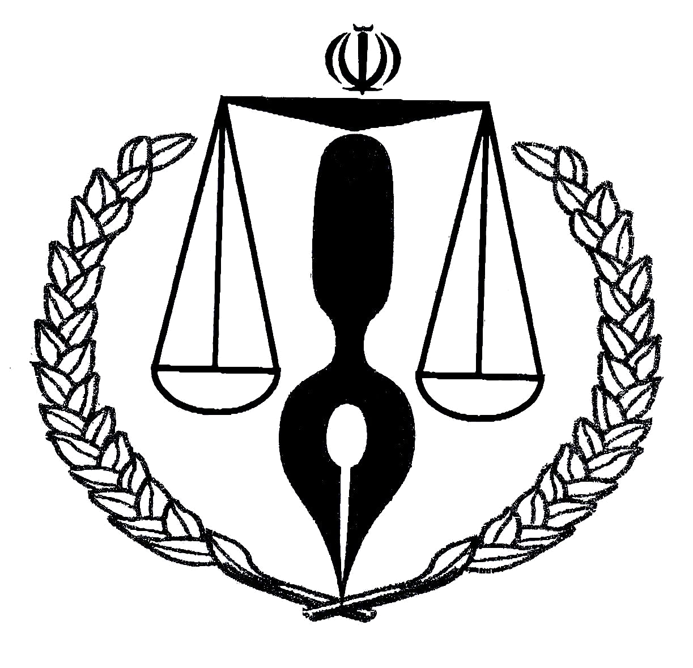
In order to assist Afghans to resolve their legal disputes before their Voluntary Repatriation, BAFIA and UNHCR, have established Dispute Settlement Committees (DSC) in a number of provinces in Iran. The aim of these committees is to review disputes regarding wages due, rent deposit reimbursement, collection of debt, family disputes, etc.

A UNHCR Hired Lawyer in the DSC can provide you with advice and guidance on how to resolve your legal problems via DSCs and/or courts. If you have a legal dispute with another person, either Iranian or Afghan, you can approach a DSC located in your local BAFIA office.

All UNHCR, United Nations Hired Lawyers and Dispute Settlement Committees’ services are free of charge

Contact Information in Iran

Persian Gulf Administrative Centre (Tehran)
Address: Fath highway, After Shahrakeh Aseman, Beginning of Tehran Sar entrance
Tel: (021) 44 56 31 48
Working hours: Sunday and Wednesday, 9 a.m. to 11:30 a.m.

UNHCR Tehran
Address: No. 3, East Emdad Alley, North Sheikh Bahaei, Vanak
Tel: (021) 88 21 25 20
Working hours: Sunday to Wednesday, 8:30 a.m. to 4 p.m.

UNHCR Esfahan
Address: Kaveh Blvd., Jaber Ansari St., Aref Str., No. 21 & 59
Tel: +98 (031) 34 44 28 41
Working hours: Sunday to Wednesday, 8:30 a.m. to 4 p.m.

UNHCR Shiraz
Address: Modarres Blvd., Janbazan Blvd., (Poodanak), Parvin Etesami Blvd., (20 Metri 5th Poodanak), opposite Khaki football field
Tel: (071) 37 22 96 92
Working hours: Sunday to Wednesday, 8:30 a.m. to 4 p.m.

UNHCR Kerman
Address: Jomhuri Eslami Blvd., Hezar o yek shab alley, No. 42
Tel: (034) 32 47 68 50
Working hours: Sunday to Wednesday, 8:30 a.m. to 4 p.m.

UNHCR Mashhad
Address: No. 45, Sajjad Blvd., between Milad junction and Bahar junction
Tel: (051) 37 68 56 41
Working hours: Sunday to Wednesday, 8:30 a.m. to 4 p.m.

UNHCR Dogharoun
Address: Ansar settlement, Dogharoun Customs, Taybad
Tel: (051) 54 55 73 55
Working hours: Sunday to Wednesday, 8:30 a.m. - 1:30 p.m. Thursdays 8:30 a.m. to 12:30 a.m.

UNHCR Iran Protection Mailbox - irnteprt@unhcr.org

Contact information in Afghanistan

Herat/Gazargah Transit/Encashment Center
Address: Around 5 KM away from the Center of Herat City in the north along the road to the Shrine of Khawja Abdullah Ansari
Tel: +93 729 868 381 operational during official working hours (08:00 – 4:30 pm)
Working hours: Sunday – Thursday, 8 a.m. – 5 p.m. and Friday, 8 a.m. – 12 p.m.
Note: transit facilities: 24 hours/7 days. Each returnee family/individual can stay in the transit center for 24 hours and in case of need (exceptional situation) up to 72 hours.

Kabul Encashment Center
Address: Kabul – Jalalabad Road, next to Tangi Gharoo, close to Jalalabad Bus Station
Tel: +93 729 128 635 operational during official working hours (08:00 – 4:30 pm)
Working hours: Sunday – Thursday, 8 a.m. – 2 p.m.

Jamal Mayna/Kandahar Encashment Center
Address: Kandahar-Spin Boldak Highway, 4 km from Shur Andam Kutal towards Kabul Dorahi on the right side of the road
Tel: +93 708 081 802 operational during official working hours (08:00 – 4:30 pm)
Working hours: Sunday - Thursday, 8 a.m. – 4:00 p.m.

Samarkhel/Jalalabad EC
Address: Main Jalalabad-Torkham Highway, Samarkhel area close to Tagab IDP camp, Bihsud district, Nangarhar province
Open from Sunday to Thursday 08:45 to 15:45
Tel: +93 786 482 262 operational during official working hours (08:00 – 4:30 pm)

UNHCR Country Office Kabul
Address: ICON Compound, Supreme Road, District # 9, Jalalabad Road, Kabul, Afghanistan.
Working hours: Sunday – Thursday, 7:45 a.m. – 4:15 p.m.
Toll-Free Hotline numbers: +93 791 990 225, +93 790 691 746 and +93 704 996 168 (available during official working hours – Sunday – Thursday from 08:00 – 4:30 pm)

UNHCR Afghanistan Protection Mailbox - afgkaprt@unhcr.org

Awaaz inter-agency helpline

- You may also direct questions on the humanitarian response or submit complaints/feedback to the Awaaz inter-agency helpline in Afghanistan. The Awaaz helpline is free and confidential. Awaaz can be accessed by those calling from a mobile phone in Afghanistan seven days a week. Female and male agents are available who speak Dari, Pashto, Urdu, English, as well as other languages.

- Phone: 410 toll-free (only in Afghanistan)

- Website: https://awaazaf.org

For more information, please check UNHCR online help pages:

Iran help page: https://help.unhcr.org/iran

Afghanistan help page: https://help.unhcr.org/afghanistan

