COVID-19

Vaccination Program

The emvolio.gov.gr platform goes live

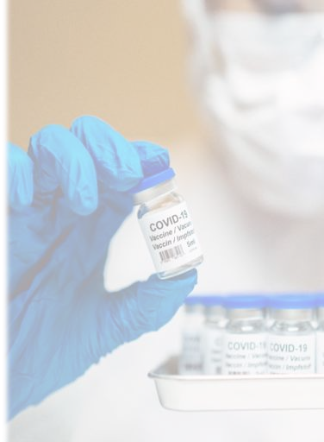

Vaccination priority check

3
Please note that citizens may also visit the nearest Citizens’ Service Center (KEP) or pharmacy to check their vaccination priority.

Search
Check whether you belong to the population group currently eligible for vaccination, using your AMKA and your last name.
Search using your AMKA
Citizens may check via the platform whether they belong to the population group currently eligible for vaccination.

4
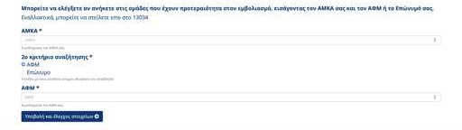Citizens may check via the platform whether they belong to the population group currently eligible for vaccination.

- Citizens may check whether they can schedule a vaccination appointment by entering their AMKA and their AFM or last name

5
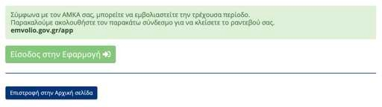Citizens may check via the platform whether they belong to the population group currently eligible for vaccination.

- Citizens may check the possibility of scheduling a vaccination appointment by entering their AMKA and AFM or last name
- If they are eligible, the platform prompts them to schedule an appointment on emvolio.gov.gr/app

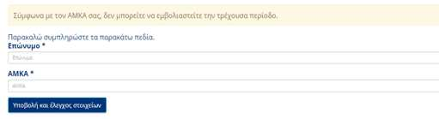Citizens may check via the platform whether they belong to the population group currently eligible for vaccination.

- Citizens may check the possibility of scheduling a vaccination appointment by entering their AMKA and AFM or last name
- If they are eligible, the platform prompts them to schedule an appointment on emvolio.gov.gr/app
- Otherwise, the platform displays an automated information message
6

13034
Citizens may check by SMS whether they belong to the population group currently eligible for vaccination.

13034

Citizens may check by SMS whether they belong to the population group currently eligible for vaccination.

  - Citizens may check whether they CAN schedule a vaccination appointment by sending a text message (SMS) with their AMKA [space] Last name, to 13034
1234567890 MATALOU
12345678901
ΜΑΤΑΛΟΥ

EMVOLIO
ΥΠΑΓΕΣΤΕ ΣΤΗΝ ΤΡΕΧΟΥΣΑ ΕΜΒΟΛΙΑΣΤΙΚΗ ΠΕΡΙΟΔΟ. ΘΑ ΠΡΕΠΕΙ ΝΑ ΟΡΙΣΕΤΕ ΡΑΝΤΕΒΟΥ ΜΕΣΩ ΤΟΥ WEB SITE
https://emvolio.gov.gr, ΣΕ ΦΑΡΜΑΚΕΙΟ Ή ΚΕΠ.
Citizens may check by SMS whether they belong to the population group currently eligible for vaccination.

YOU ARE ELIGIBLE FOR THE CURRENT VACCINATION PERIOD. YOU NEED TO SCHEDULE YOUR APPOINTMENT THROUGH https://emvolio.gov.gr, IN A PHARMACY, OR IN A KEP.
  - Citizens may check whether they CAN schedule a vaccination appointment by sending a text message (SMS) with their AMKA [space] Last name, to 13034

  - Immediately, they receive a reply from the EMVOLIO about the possibility of scheduling an appointment and are prompted to schedule it

EMVOLIO
ΔΕΝ ΥΠΑΓΕΣΤΕ ΣΤΗΝ ΤΡΕΧΟΥΣΑ ΕΜΒΟΛΙΑΣΤΙΚΗ ΠΕΡΙΟΔΟ.
Citizens may check by SMS whether they belong to the population group currently eligible for vaccination.

  - Citizens may check whether they CAN schedule a vaccination appointment by sending a text message (SMS) with their AMKA [space] Last name, to 13034
YOU ARE NOT ELIGIBLE FOR THE CURRENT VACCINATION PERIOD
  - Immediately, they receive a reply from the EMVOLIO about the possibility of scheduling an appointment and are prompted to schedule it
  - Otherwise, they receive a notification from EMVOLIO that they are not yet eligible to schedule an appointment

Application for personal details identification in case your AMKA is not found

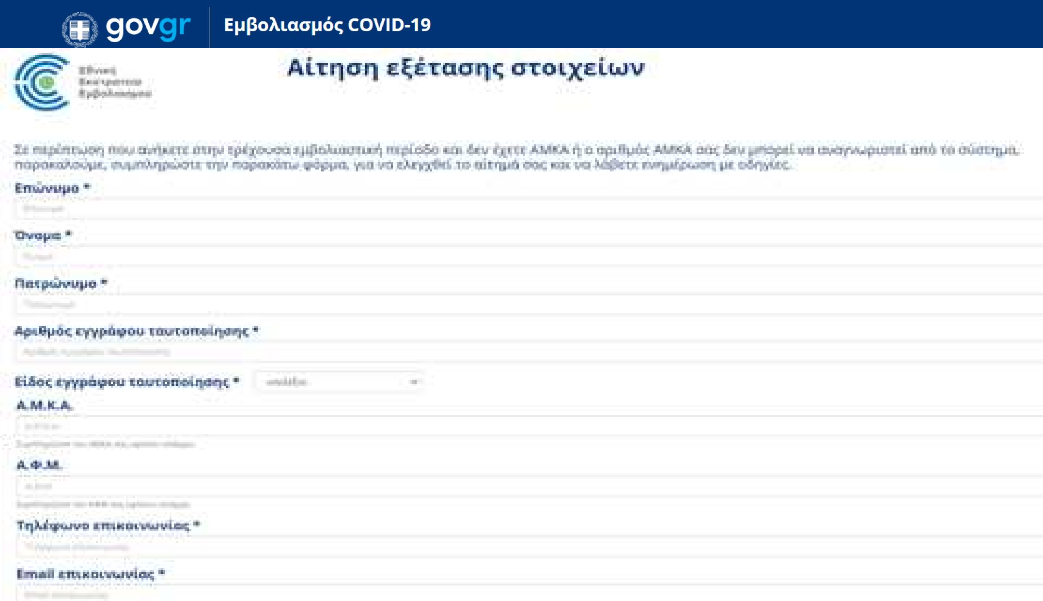In the event a citizen is eligible for the current vaccination period, but they do not have an AMKA or their AMKA is not recognized by the system, then they can visit the webpage emvolio.gov.gr/aitisi
(Application for personal details identification).
By filling in all the necessary fields and selecting “Submit”, a request is sent for examination by a competent committee.
After the examination of the request and based on the decision of the competent committee, the citizens concerned will be given the possibility to log in to the emvolio.gov.gr platform and schedule their appointment.
11

Scheduling a vaccination appointment

Scheduling a vaccination appointment
Platform, KEP, pharmacies and e-prescription

The scheduling of vaccination appointments can be carried out in the following ways:

- Via text messages (SMS), if the citizen has subscribed to the on-line platform for patient e-prescription and they are eligible to be vaccinated, as detailed below.

- Directly by the citizen, by accessing the emvolio.gov.gr platform, as detailed below.
- By visiting the nearest KEP in person, or through a third person on their behalf. Note that in the case of third persons, a solemn declaration is required, which will be incorporated into the emvolio.gov.gr platform later on. In addition, the third person needs to know the AMKA and ID number of the person concerned, or produce a photocopy thereof.

- By visiting the nearest pharmacy in person, or through a third person on their behalf. Detailed instructions and guidelines for scheduling appointments in pharmacies will be provided shortly.

13034
Citizens who have already subscribed to the e-prescription platform, and are eligible for vaccination, will receive a text message from 13034 regarding their pre-scheduled appointment.

13034
ΑΜΚΑ 12345678901 ΚΩΔ
ΡΑΝΤΕΒΟΥ 1234567890 ΘΑ ΛΑΒΕΤΕ ΝΕΟ ΜΗΝΥΜΑ ΜΕ ΤΟ ΡΑΝΤΕΒΟΥ ΕΜΒΟΛΙΑΣΜΟΥ ΣΑΣ. ΕΠΙΒΕΒΑΙΩΣΗ ΕΝΤΟΣ 72 ΩΡΩΝ
ΡΑΝΤΕΒΟΥ 1 19/02/21 ΩΡΑ 08:00, ΣΤΟ ΕΜΒΟΛΙΑΣΤΙΚΟ ΚΕΝΤΡΟ ΑΜΑΡΟΥΣΙΟΥ ΔΙΓΕΝΗ ΑΚΡΙΤΑ 12. ΠΡΟΣΕΛΕΥΣΗ 15 ΛΕΠΤΑ ΠΡΙΝ. ΟΔΗΓΙΕΣ ΣΕ ΝΕΟ ΜΗΝΥΜΑ
ΑΝ ΣΥΜΦΩΝΕΙΤΕ ΜΕ ΤO ΡΑΝΤΕΒΟΥ, ΣΤΕΙΛΤΕ ΣΤΟ 13034 ΤΟ ΜΗΝΥΜΑ 1234567890. ΑΛΛΑΓΗ ΡΑΝΤΕΒΟΥ ΣΕ ΦΑΡΜΑΚΕΙΑ, ΚΕΠ ΚΑΙ EMVOLIO.GOV.GR
Citizens who have already subscribed to the e-prescription platform, and are eligible for vaccination, will receive a text message from 13034 regarding their pre-scheduled appointment.
ΑΜΚΑ 12345678901, APPOINTMENT CODE 1234567890, YOU WILL RECEIVE A NEW MESSAGE WITH YOUR VACCINATION APPOINTMENT. PLEASE CONFIRM WITHIN 72 HOURS.

  - Citizens are informed through text messages (SMS) from 13034 about their appointment pre-scheduling.
APPOINTMENT 1 ON 19/02/21, AT 08:00, VACCINATION CENTER OF AMAROUSION, 12 DIGENI AKRITA STR. PLEASE COME IN 15 MINUTES EARLIER. INSTRUCTIONS IN NEW MESSAGE.
IF YOU AGREE WITH THE APPOINTMENT, PLEASE SEND THE MESSAGE 1234567890 TO 13034. APPOINTMENT CHANGES IN PHARMACIES, KEP AND ON EMVOLIO.GOV.GR

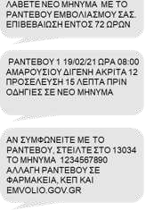
13034

Citizens who have already subscribed to the e-prescription platform, and are eligible for vaccination, will receive a text message from 13034 regarding their pre-scheduled appointment.
RECEIVE A NEW MESSAGE WITH YOUR VACCINATION APPOINTMENT. PLEASE CONFIRM WITHIN 72 HOURS.

APPOINTMENT 1 ON 19/02/21, AT 08:00, VACCINATION CENTER OF AMAROUSION, 12 DIGENI AKRITA STR. PLEASE COME IN 15 MINUTES EARLIER. INSTRUCTIONS IN NEW MESSAGE.
  - Citizens are informed through text messages (SMS) from 13034 about their appointment pre-scheduling.
  - Citizens have the possibility to confirm their appointment by SMS, within 72 hours; otherwise, the slot is released.
1234567890
IF YOU AGREE WITH THE APPOINTMENT, PLEASE SEND THE MESSAGE 1234567890 TO 13034. APPOINTMENT CHANGES IN PHARMACIES, KEP AND ON EMVOLIO.GOV.GR
1234567890

EMVOLIO
ΤΟ ΡΑΝΤΕΒΟΥ ΜΕ ΚΩΔΙΚΟ 1234567890 ΕΠΙΒΕΒΑΙΩΘΗΚΕ. ΕΜΒΟΛΙΑΣΜΟΣ 19/02/21 ΩΡΑ 08:00 ΣΤΟ ΕΜΒΟΛΙΑΣΤΙΚΟ ΚΕΝΤΡΟ ΑΜΑΡΟΥΣΙΟΥ ΔΙΓΕΝΗ ΑΚΡΙΤΑ 12.
Citizens who have already subscribed to the e-prescription platform, and are eligible for vaccination, will receive a text message from 13034 regarding their pre-scheduled appointment.
APPOINTMENT WITH CODE 1234567890 IS CONFIRMED. VACCINATION ON 19/02/21, AT 08:00, AT THE VACCINATION CENTER OF AMAROUSION, 12 DIGENI AKRITA STR.

  - Citizens are informed through text messages (SMS) from 13034 about their appointment pre-scheduling.
  - Citizens have the possibility to confirm their appointment by SMS, within 72 hours; otherwise, the slot is released.
  - Citizens receive an immediate response from EMVOLIO regarding successful confirmation
In case a citizen wishes to modify their pre-scheduled appointment, they need to access the emvolio.gov.gr platform.

18

Accessing the platform
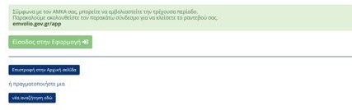Having checked their eligibility for vaccination for the current period, citizens follow the link emvolio.gov.gr/app, as prompted by the platform, to schedule their appointment.

Note that citizens may also schedule an appointment by visiting the nearest Citizens’ Service Center (KEP) or pharmacy.

19

Accessing the platform
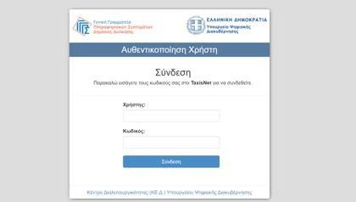Having checked their eligibility for vaccination for the current period, citizens follow the link emvolio.gov.gr/app, as prompted by the platform, to schedule their appointment.

- Citizens are connected to the platform using their TAXISNET credentials.

20

Accessing the platform
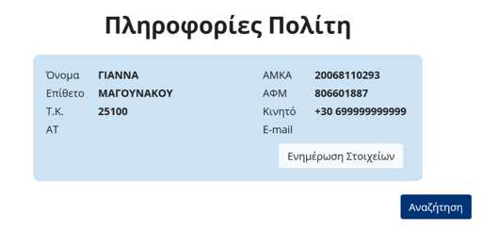Having checked their eligibility for vaccination for the current period, citizens follow the link emvolio.gov.gr/app, as prompted by the platform, to schedule their appointment.

ΜΑΤΑΛΟΥ (MATALOU)
- Citizens are connected to the platform using their TAXISNET credentials.

- After logging in successfully, citizens confirm that their personal details are correct.

Accessing the platform
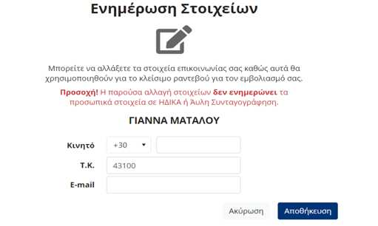Having checked their eligibility for vaccination for the current period, citizens follow the link emvolio.gov.gr/app, as prompted by the platform, to schedule their appointment.

- Citizens are connected to the platform using their TAXISNET credentials.

- After logging in successfully, citizens confirm that their personal details are correct.
- Citizens can make additions/corrections
21

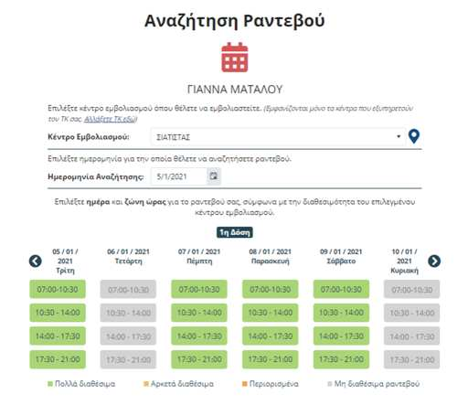
22

Scheduling an appointment
After logging in successfully, citizens take the following steps to schedule their appointment:

- First, they schedule the appointment to receive the first dose of the vaccine

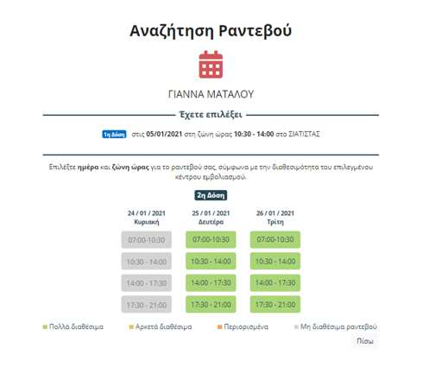
23

Scheduling an appointment
After logging in successfully, citizens take the following steps to schedule their appointment:
- First, they schedule the appointment to receive the first dose of the vaccine
- Then, they schedule the follow-up appointment (second dose of the vaccine)

Scheduling an appointment
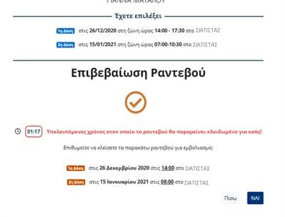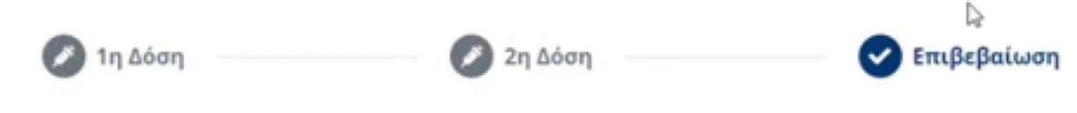After logging in successfully, citizens take the following steps to schedule their appointment:
- First, they schedule the appointment to receive the first dose of the vaccine
- Then, they schedule the follow-up appointment (second dose of the vaccine)
- Then, citizens must check the appointment details and confirm it within two (2) minutes
24

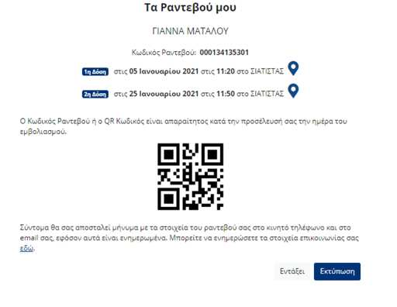

Scheduling an appointment
After logging in successfully, citizens take the following steps to schedule their appointment:
- First, they schedule the appointment to receive the first dose of the vaccine
- Then, they schedule the follow-up appointment (second dose of the vaccine)
- Then, citizens must check the appointment details and confirm it within two (2) minutes
24
- Finally, they save/print the details of their appointment and the QR code
25

26

Modifying an appointment
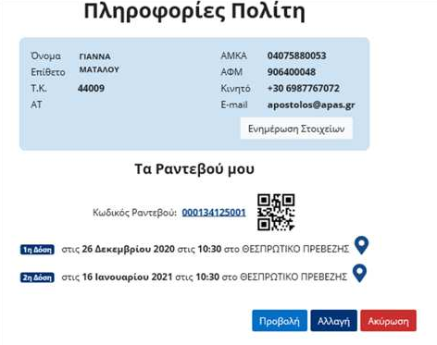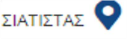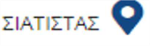Citizens may modify or cancel their appointment, taking into consideration the following:
- A change/cancellation can be made, up to three (3) days before the scheduled date

27

Modifying an appointment
Citizens may modify or cancel their appointment, taking into consideration the following:
- A change/cancellation can be made, up to three (3) days before the scheduled date
- Citizens have the opportunity to change/cancel their appointment only once

Modifying an appointment
Citizens may modify or cancel their appointment, taking into consideration the following:
- A change/cancellation can be made, up to three (3) days before the scheduled date
- Citizens have the opportunity to change/cancel their appointment only once
- In case of cancellation or no-show, citizens will not be able to reschedule for the next thirty (30) days.
28

Vaccination appointment reminder

13034
Citizens are informed by SMS about the details of their appointment

13034
1234567890
or 12345678901 MATALOU
Citizens are informed by SMS about the details of their appointment

  - Citizens can request a reminder for the details of their appointment by sending an SMS to 13034 with the Appointment Code or their AMKA and surname (AMKA[space]surname)

EMVOLIO
ΣΑΣ ΥΠΕΝΘΥΜΙΖΟΥΜΕ ΤΟ ΡΑΝΤΕΒΟΥ ΓΙΑ ΕΜΒΟΛΙΑΣΜΟ ΚΑΤΑ COVID-19: ΣΤΙΣ 19/02/21 ΩΡΑ 08:00 ΣΤΟ ΕΜΒΟΛΙΑΣΤΙΚΟ ΚΕΝΤΡΟ ΑΜΑΡΟΥΣΙΟΥ ΔΙΓΕΝΗ ΑΚΡΙΤΑ 12
Citizens are informed by SMS about the details of their appointment

WE REMIND YOU THE APPOINTMENT FOR VACCINATION AGAINST COVID-19: ON 19/02/21 AT 08:00 AT THE VACCINATION CENTER OF AMAROUSIO, 12 DIGENI ACRITA STR.
  - Citizens can request a reminder for the details of their appointment by sending an SMS to 13034 with the Appointment Code or their AMKA and surname (AMKA[space]surname)

  - Citizens receive an immediate response from EMVOLIO providing the details of the appointment

EMVOLIO
ΣΑΣ ΥΠΕΝΘΥΜΙΖΟΥΜΕ ΤΟ ΡΑΝΤΕΒΟΥ ΓΙΑ ΕΜΒΟΛΙΑΣΜΟ ΚΑΤΑ COVID-19: ΣΤΙΣ 19/02/21 ΩΡΑ 08:00 ΣΤΟ ΕΜΒΟΛΙΑΣΤΙΚΟ ΚΕΝΤΡΟ ΑΜΑΡΟΥΣΙΟΥ ΔΙΓΕΝΗ ΑΚΡΙΤΑ 12
Citizens are reminded by SMS about the details of their appointment

WE REMIND YOU THE APPOINTMENT FOR VACCINATION AGAINST COVID-19: ON 19/02/21 AT 08:00 AT THE VACCINATION CENTER OF AMAROUSIO, 12 DIGENI ACRITA STR.

  - Furthermore, citizens will receive three (3) automated SMS reminders of the appointment from EMVOLIO, as follows:
    - 3 days before the appointment
    - 1 day before the appointment
    - at 7 a.m. on the day of the appointment

